**Write gradually growing logs into hdfs – Flume**

**Flume**

Flume is a standard, simple, robust, flexible, and extensible tool for data ingestion from various data producers (webservers) into Hadoop.

**Pros**

* Central master server manages all nodes

**Flume-ng**

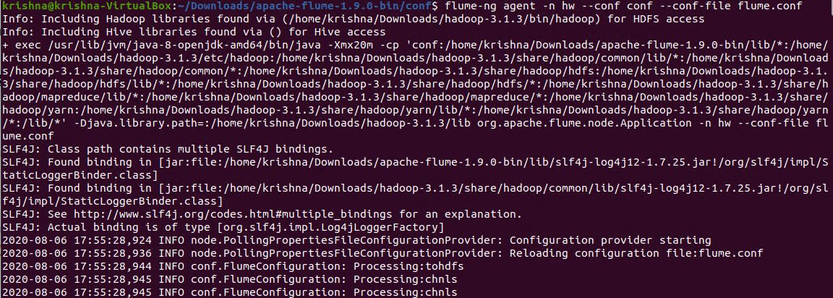

In the above screenshot, we can see the flume-ng command running an hw agent with flume.conf configuration.

**Writing into output.txt**



In the above screenshot, linux_message_3000lines.txt start writing logs to ouput.txt file with .2 seconds of sleep.

**Writing of data into HDFS**

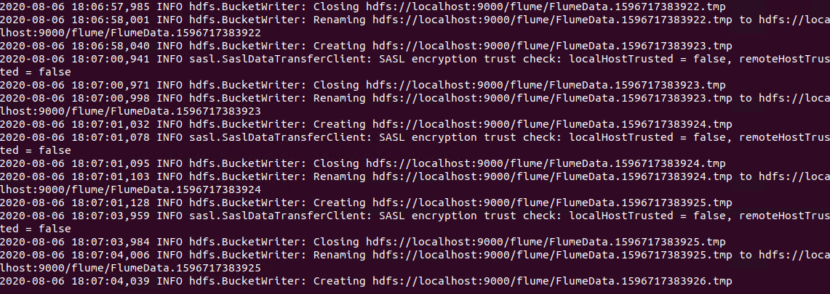

In the above screenshot, flume is start writing data into hdfs.

**Output:**

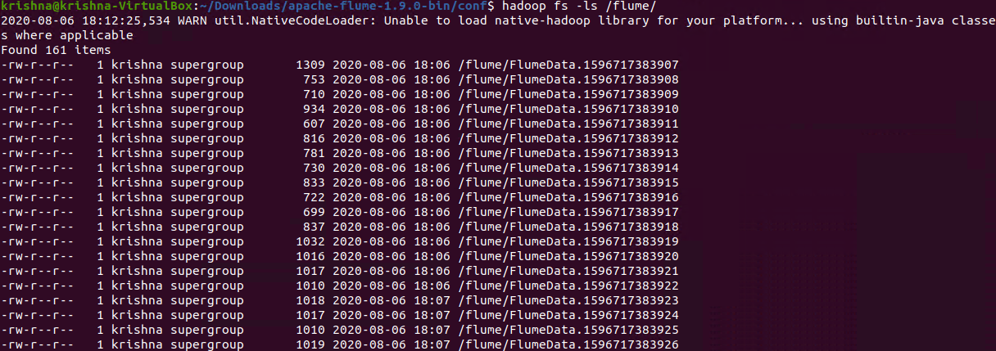

In the above screenshot, we can see that all data of output.txt is present in multiple files.